**Analysis on bank customer’s data**

Table of content:

* Introduction
* Methodology
* Results
* Conclusion

I hereby declare that this project work titled, “ANALYSIS ON BANK CUSTOMER’S DATA” submitted to IUNGO SOULTIONS (Fintech Academy).

I heartily thank all tutors in the IUNGO SOLUTIONS for their encouragement and support. I thank everyone whose names are mentioned or not mentioned here for bringing out this project successfully.

**INTRODUCTION:**

Bank customer churn data plays an important role in the banks. It is the situation when the customers close their bank accounts, discontinue the use of banking services, or transfer their financial activities to another bank. It means loss of customers or clients in the bank. It is a measure of customer turnover within the banking sector. If the rate of customer churn is high, it will affect the bank's profits. It will also impact the bank negatively and overall business performance.

Some of the reasons for the bank customer churn:

* Better digital experience
* High interest rates
* Poor customer service
* Lack of engagement with the customers
* Delay in solving the problems/issues

To effectively manage customer churn, most banks will focus on implementing new strategies to retain existing customers and attract new customers.

**METHODOLOGY:**

The project is entitled “**BANK CUSTOMER CHURN ANALYSIS**” This data is collected from the Kaggle website; this dataset has data of customers in the bank across Germany, France, and Spain with 10,000 records. Here is a small brief about the data.

18 columns and its brief:

To analyze this bank churn data I used the visualization tool called Tableau which is powerful and interactive. This business intelligence tool helps me to visualize the patterns in the data. I explore and analyze the data through visual representations like tables, graphs, and dashboards. I created dynamic and interactive dashboards and reports using Tableau, which can be shared, easy to use, and understandable.

**RESULTS:**

Main Dashboard

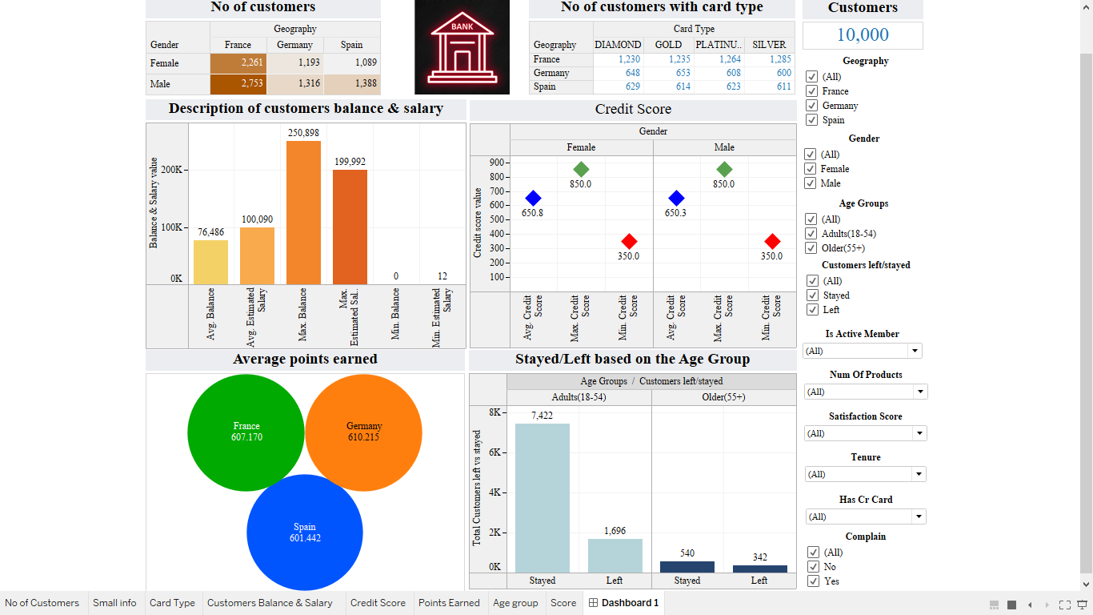

* From this dashboard, It shows the overall data of customers in the bank. The top right shows the total records in this dataset.
* Following to that there are two tables with No of customers with card type and no of customers in three countries gender-wise information.
* In the bar graph shows that information about the customer's balance and estimated salary (Average, minimum & maximum).
* The next graph is named Credit Score, same bar graphs information like Average, minimum & maximum credit scores between males and females.
* Bubble chart shows the average point earned by all the customers in three countries. There is only a small difference between the three countries.
* Bar graph in the bottom corner shows the count of who left and stayed with the bank and is categorized by age group (Adults 18-54, older 55+).
* Finally, the filters on the right side of the dashboard are really interesting. Here are some filters that included - Geography, Gender, Age group, customer who stayed/left, is active member, No of products, Satisfaction score, tenure(no of years as a client), has a credit card, and, complaints.

You can interact with the dashboard that I have provided along with this file.

Results of customers who left

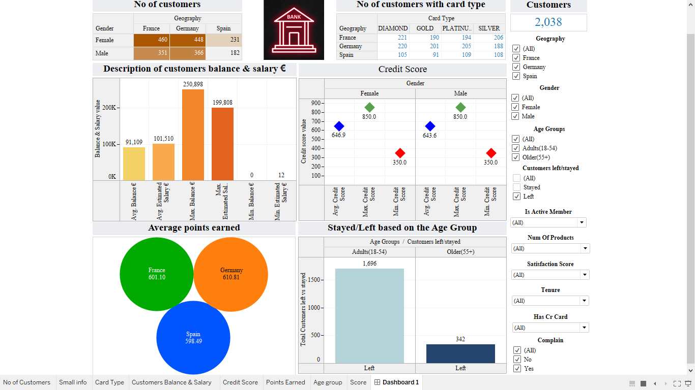

* This dashboard shows the information of customers who left the bank. A total of 2038 customers were left in that, 1696 are adults (18-54) age group and 342 are older (55+) age group. Adults are more tend to change or leave the bank.
* In gender base, Graph that those who left the bank are more females than males over the three countries.
* Among the three countries, Spain earned fewer points from that bubble chart.

Who left and complain

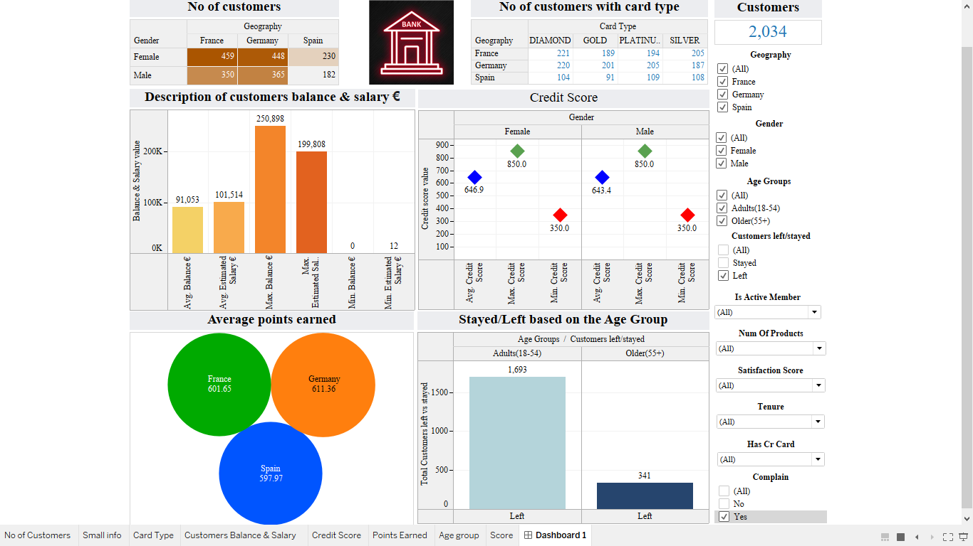

* From this dashboard, graphs shows that most of the customers who left they have some complaints, only 4 customers left without any complaints.
* By this, we can assume there must be some reason to leave that bank or move their accounts to another bank.

Who left and having credit card

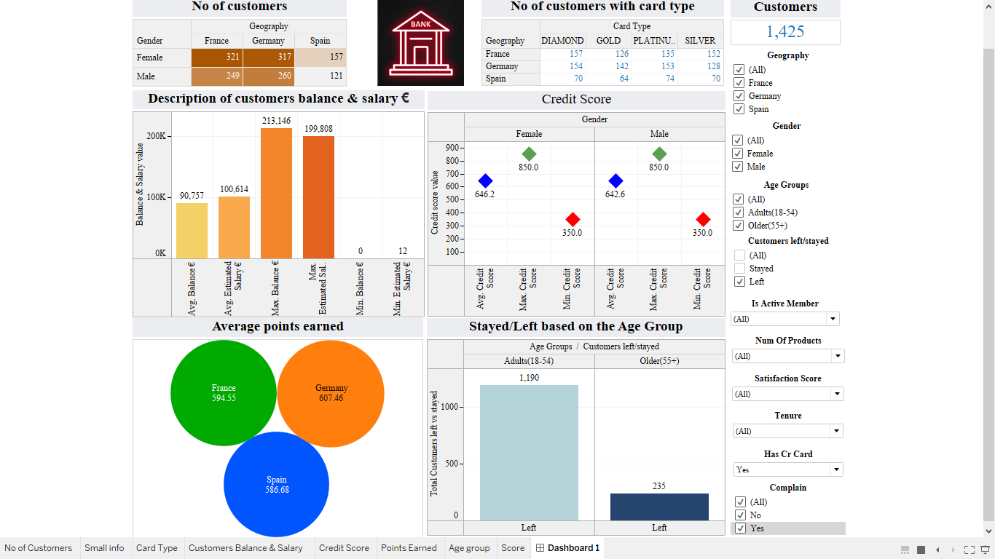

* In the above dashboard, information about people whose having credit cards with the bank and left the bank. Approximately 70% of customers left the bank in this category.
* Losing the credit card holders may affect the bank's profits in the business.

Who left with satisfaction score

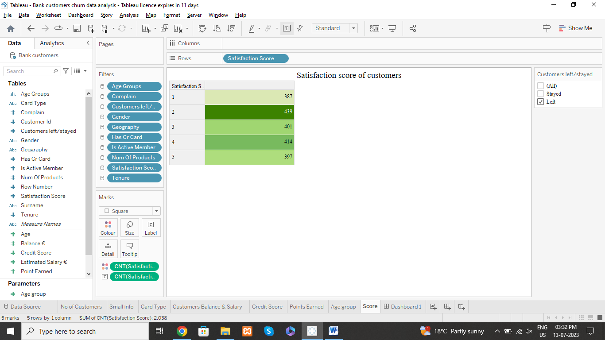

* The above satisfaction score is from the customers who left the bank. The highest count of satisfaction scores is 2.
* The above table shows that the customer is disappointed somewhere with bank services. The bank should inspect this feedback to come over this issue.

Who stayed and their satisfaction score

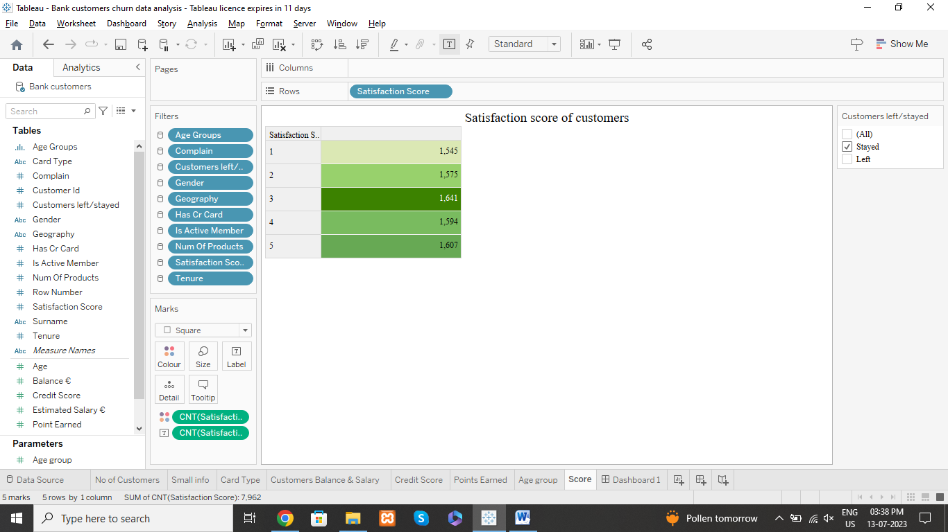

* The customers who stayed with the bank and their satisfaction score. Most of them were ranked as 3 and above.
* Still, it looks like customers are neutral, the bank should come up with new implementations and strategies to keep the existing customers and attract the new customers.

**CONCLUSION:**

Based on the analysis conducted, several key findings emerge. Firstly, it is evident that most of the customers who decided to leave the bank fall within the age range of 18-54. Notably, a higher concentration of female customers can be observed among those who chose to leave. This observation highlights the need for further investigation into the reasons behind this gender disparity. This analysis also discovered that about 70% of the customers who left had credit cards. This could have an impact on the bank's profits. The bank should investigate why these customers are leaving and try to address their concerns. Another important finding is that all the customers who left had complained to the bank. This highlights the need for the bank to improve its complaint-handling process and make sure that customer concerns are addressed properly. Furthermore, we noticed that many of the customers who left gave a satisfaction score of 2, indicating a low level of satisfaction. On the other hand, most of the customers who stayed with the bank gave a score of 3 or higher. The bank should focus on improving overall customer satisfaction and providing better service.

Based on these findings, the bank should implement new strategies to address the issues identified. This includes understanding why more women are leaving, improving complaint resolution, and ensuring high standards of service. The bank should also work on attracting new customers to improve its profits.

In conclusion, this analysis provides important information for the bank to take action and improve customer retention, while also attracting new customers to grow its business.